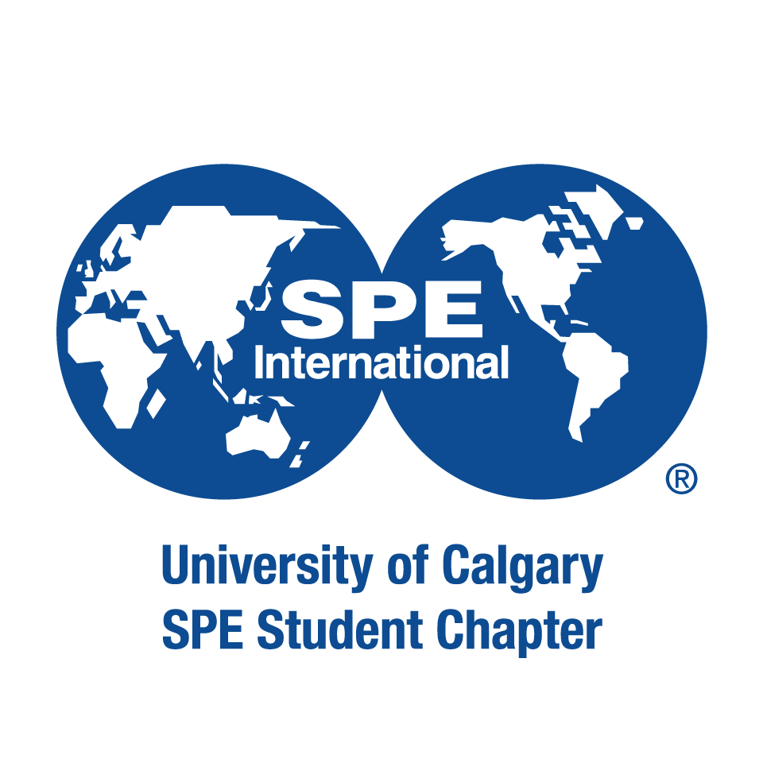

This application form is a requirement for ALL council positions (President, Vice President, Director, and Representative positions). Presidential and senior applicants should consult Page 7 of the Executive Transition Document for additional requirements. All applicants are preferred to be 2021 – 2022 student members of the Petroleum & Energy Society to seek a position on council.
Senior council, director, and representative applications are due on April 3, 2022, at 11:59pm MST.
Applicant Information:
First and Last Name:
Faculty of Studies:
Concentration/Discipline:
Current Year of Studies:
Email Address:
Cell Phone Number:

Council Position:

Extra-Curricular Activities
In 200 words or less, please summarize any extra-curricular activities and past PES involvement (if any), that demonstrate your student initiative and leadership qualities

Goals and Vision
In 200 words or less, please summarize your main reasons for wanting to join the PES council, and any important skills you have that you think will benefit the club in achieving its goals.

Please ensure all sections of the application have been filled out completely and submit via email to the current Vice President Communications Arby Seño at ruelbenedict.seno@ucalgary.ca. The council will review your application, and results will be released soon after the council selection meeting.

Thank you for your application and interest in the Petroleum & Energy Society!

