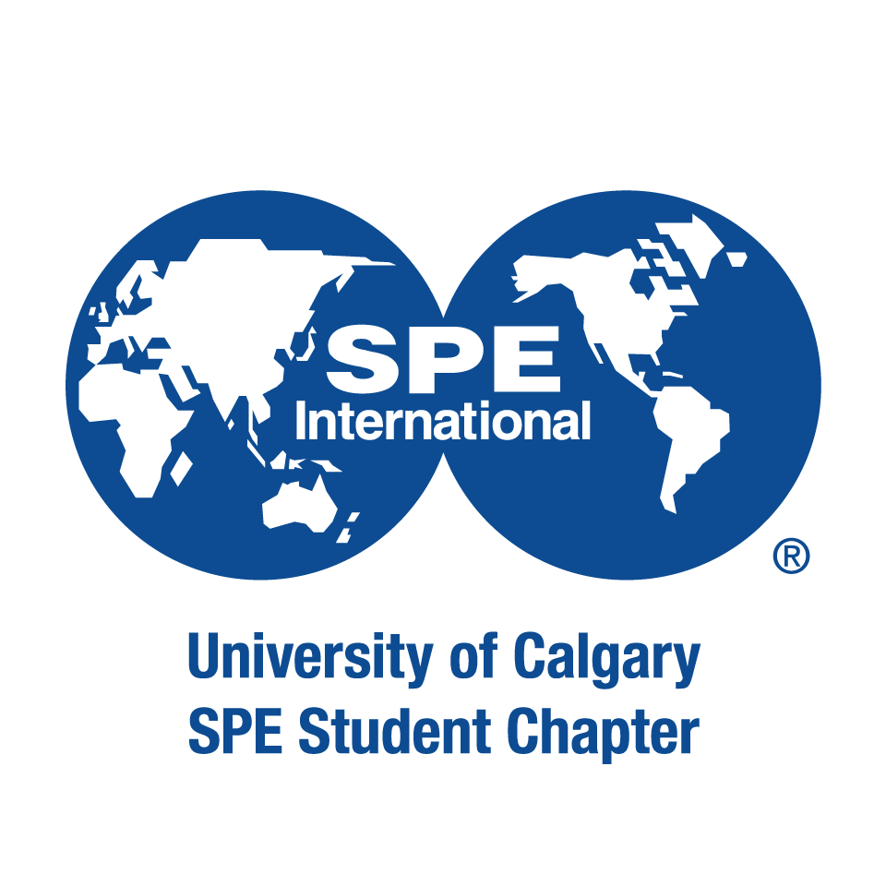

This application form is a requirement for all council positions (President, Vice President, Director, and Representative positions). Information about each position should consult in the Executive Transition Document 2023 for additional requirements. All applicants are preferred to be 2023 – 2024 student members of the Petroleum & Energy Society to seek a position on the council.
Senior council, director, and representative applications are due on April 30, 2023, at 11:59 pm MST.
Applicant Information:
First and Last Name:
Faculty of Studies:
Concentration/Discipline:
Current Year of Studies:
Email Address:
Cell Phone Number:
Council Position:

Extra-Curricular Activities
In 200 words or less, please summarize any extra-curricular activities and past PES involvement (if any), that demonstrate your student initiative and leadership qualities

Goals and Vision
In 200 words or less, please summarize your main reasons for wanting to join the PES council, and any important skills you have that you think will benefit the club in achieving its goals.

Please ensure all sections of the application have been filled out completely and submit via email to the current President Anita Malekian at anita.malekian@ucalgary.ca The council will review your application, and results will be released soon after the council selection meeting.

Thank you for your application and interest in the Petroleum & Energy Society!

